Binary Search(Iterative + Recursive)

#include <bits/stdc++.h>

using namespace std;

int iterative(int \*arr, int n, int target)

{

int lo = 0, hi = n;

int ans = -1;

while(lo <= hi)

{

int mid = (lo + hi)/2;

//cout << mid << endl;

if(arr[mid] < target)

{

lo = mid + 1;

}

else if(arr[mid] == target)

{

ans = mid;

break;

}

else

{

hi = mid - 1;

}

}

return ans;

}

int recursive(int lo, int hi, int \*arr, int target)

{

if(lo > hi)return -1;

int mid = (lo + hi)/2;

if(arr[mid] == target)return mid;

if(arr[mid] < target)return recursive(mid + 1, hi, arr, target);

if(arr[mid] > target)return recursive(lo, mid - 1, arr, target);

}

int main()

{

cout << "Enter number of elements then elements\n";

int n; cin >> n;

int arr[n];

for(int i = 0; i < n; i++)

{

cin >> arr[i];

}

for(int i = 0; i < n - 1; i++)

{

for(int j = 0; j < n - i - 1; j++)

{

if(arr[j] > arr[j + 1])

{

swap(arr[j + 1], arr[j]);

}

}

}

cout << "Enter the number to search\n";

int target;

cin >> target;

int a1 = iterative(arr, n, target);

int a2 = recursive(0, n, arr, target);

if(a1 != -1)cout << "Element found by iterative binary search at " << a1 << "\n";

else cout << "Element NOT found by iterative binary search\n";

if(a2 != -1)cout << "Element found by recursive binary search at " << a2 << "\n";

else cout << "Element NOT found by recursive binary search\n";

//for(auto &i: arr)cout << i << " ";

}

START CASE:

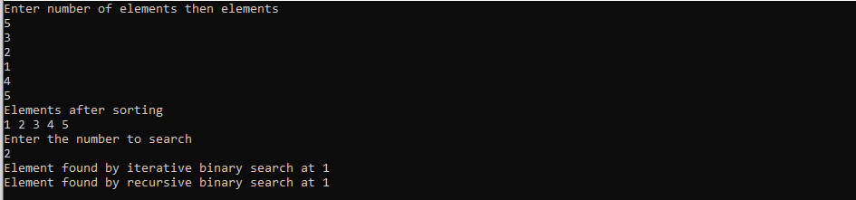

MIDDLE CASE:

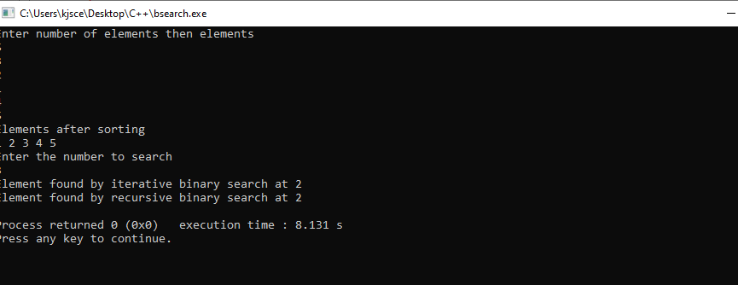

ENDCASE:  
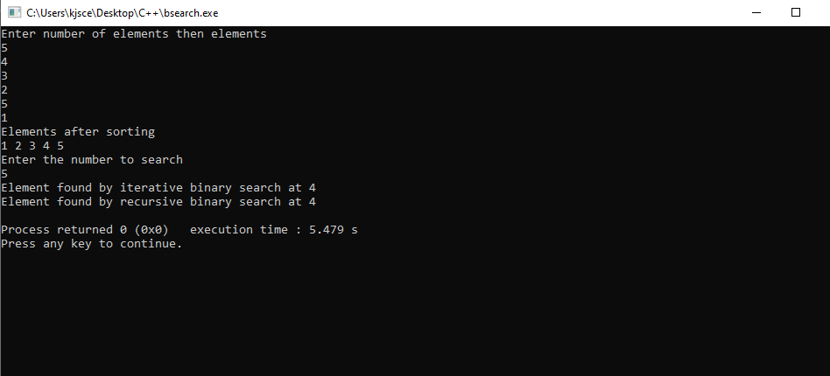

NOT FOUND CASE:

